**ELaNa XX**

**Vanderbilt University / AMSAT-NA**



**RadFXSat-2** **Bakeout Test Report**

## Satellite Team Change Log

|  |  |  |  |
| --- | --- | --- | --- |
| **Revision** | **Date** | **Author** | **Change Log** |
| 0 | 6/30/2018 | Robert Davis | Initial write |

## Satellite Team Responsible Engineer

|  |  |
| --- | --- |
| **Author** | **Contact** |
| Robert Davis | KF4KSS@amsat.org |
| Gerald Buxton | foxse@n0jy.org |

**Purpose**

The purpose of this document is to outline the results for thermal vacuum (T-Vac) bakeout of RadFXSat-2. It is a 1U CubeSat. It will launch on ELaNa XX, in a Xtenti FRA-R3S. Bakeout is performed to remove any potentially outgassing materials from the CubeSat according to L1-VCLS-ICD-21 (ICD ¶3.6.5.3) and L1-VCLS-ICD-22 (ICD ¶3.6.5.3.1). Bakeout was performed at NTS-Boxborough, MA on June 20, 2018. The Extended Duration Profile of 60°C was held for six hours, at better than 1x10^-4 Torr.

**Requirements Verified**

* **L1-VCLS-ICD-21** – The UCPs shall perform a thermal vacuum bakeout at a high vacuum level (minimum 1x10^-4 mm Hg (Torr).
* **L1-VCLS-ICD-22** – The UCPs shall test to one of the two following bakeout profiles, depicted graphically in [ICD] Figure 3-18.
  + Standard UCP Profile: The UCP will be exposed to a temperature held at 70°C for three hours.
  + Extended Duration Profile: The UCP will be exposed to a temperature held at 60°C for six hours.

**Test Levels**

RadFXSat-2 was subjected to the Extended Duration Profile thermal vacuum bakeout with a minimum vacuum level of 1*x*10*−*4 Torr and a minimum temperature of 60ºC, with a dwell time of at least 6 hours.

**Thermal Vacuum Hardware**

Table 1 Hardware

|  |  |
| --- | --- |
| **RadFXSat-2** | Flight Unit |
| **Test Chamber** | Thermal Vacuum Chamber #CH330 at  NTS Boxborough  1146 Massachusetts Ave  Boxborough, MA 01719 |
| **Temperature Sensors** | Type-T Thermocouples |
| **Gauge(s)** | Varian Ionization Gauge 843  Agilent Technologies Glass Ion Gauge 572 |
| **Data Acquisition** | Agilent Technologies DAQ 34970A |

**AMSAT-NA personnel present**

Robert Davis, bakeout test lead, alternate chamber operator.

Burns Fisher, electrical test.

Eric Skoog, electrical test.

**NTS personnel present**

George Pelletier, chamber test lead.

Harry Lampas, alternate chamber operator.

**Bakeout Test Sequence**

* + Ramp to vacuum pressure
  + Ramp to vacuum temperature
  + Dwell for 6 hours
  + Drift overnight to intermediate temperature approaching ambient
  + Vent to ambient pressure
  + Drift to ambient temperature

**Reference Documents**

As-run “RadFxSat-2 Bakeout Procedure”, rev 0.

As-run manual log of temperatures and pressure.

“PRO78417 Amsat Thermal Bakeout Graph.xlsx” by NTS [DAQ temperatures].

“Thermal Bakeout.xlsx” by NTS [program and manual log].

“CC-PRO78417, Rev. 0 AMSAT, 06-28-18.pdf” by NTS [Certificate of Conformance to procedures].

**Results**

RadFXSat-2 thermal vacuum bakeout was completed on June 20, 2018 at NTS Boxborough.

The chamber’s Hot/Cold Plate was driven, and AMSAT’s Thermal Hat was used to reduce the gradient top to bottom of RadFXSat-2. The –Z face was facing upward. Therefore it was farthest from the Hot Plate, and expected to be coldest exterior surface of RadFXSat-2.

Two thermocouples were used, on opposite corners (Rails). Temperature requirement was considered met when both thermocouples reached 60°C.

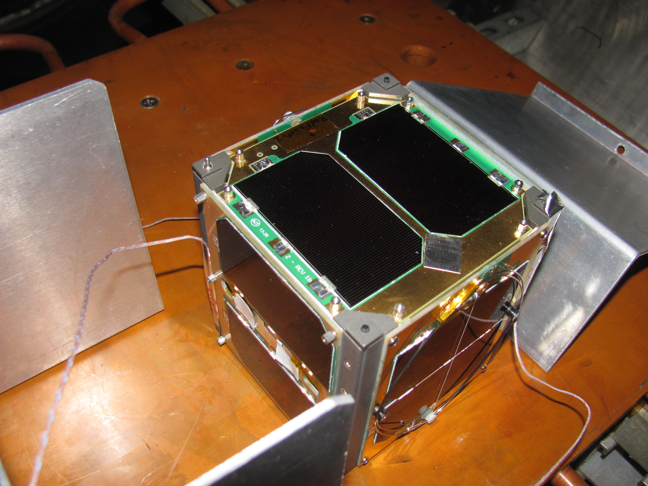

Figure 1 Thermocouples placed on Rails near diagonal (+X+Y–Z and –X–Y+Z) corners

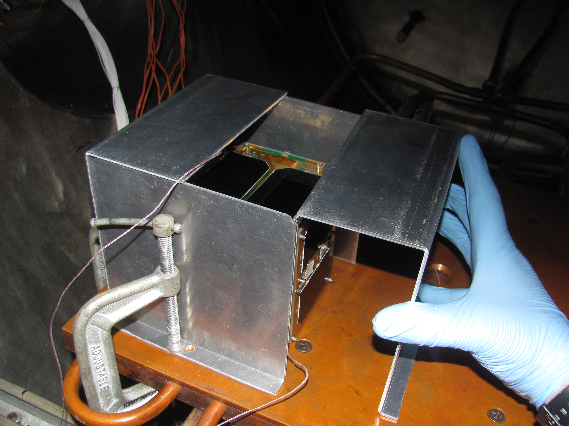

Figure 2 Bakeout Hat was assembled around RadFXSat-2 to minimize thermal gradient.

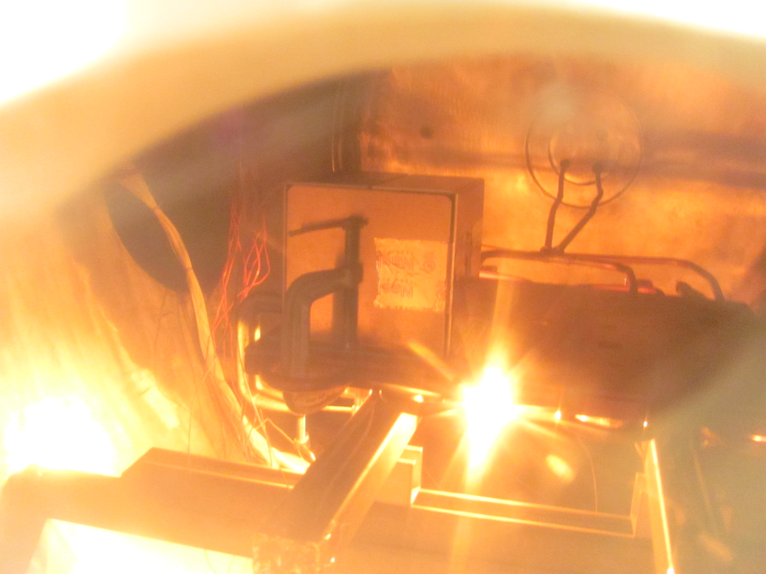

Figure 3 View inside chamber during test, illuminated by heater lamp during pulse.

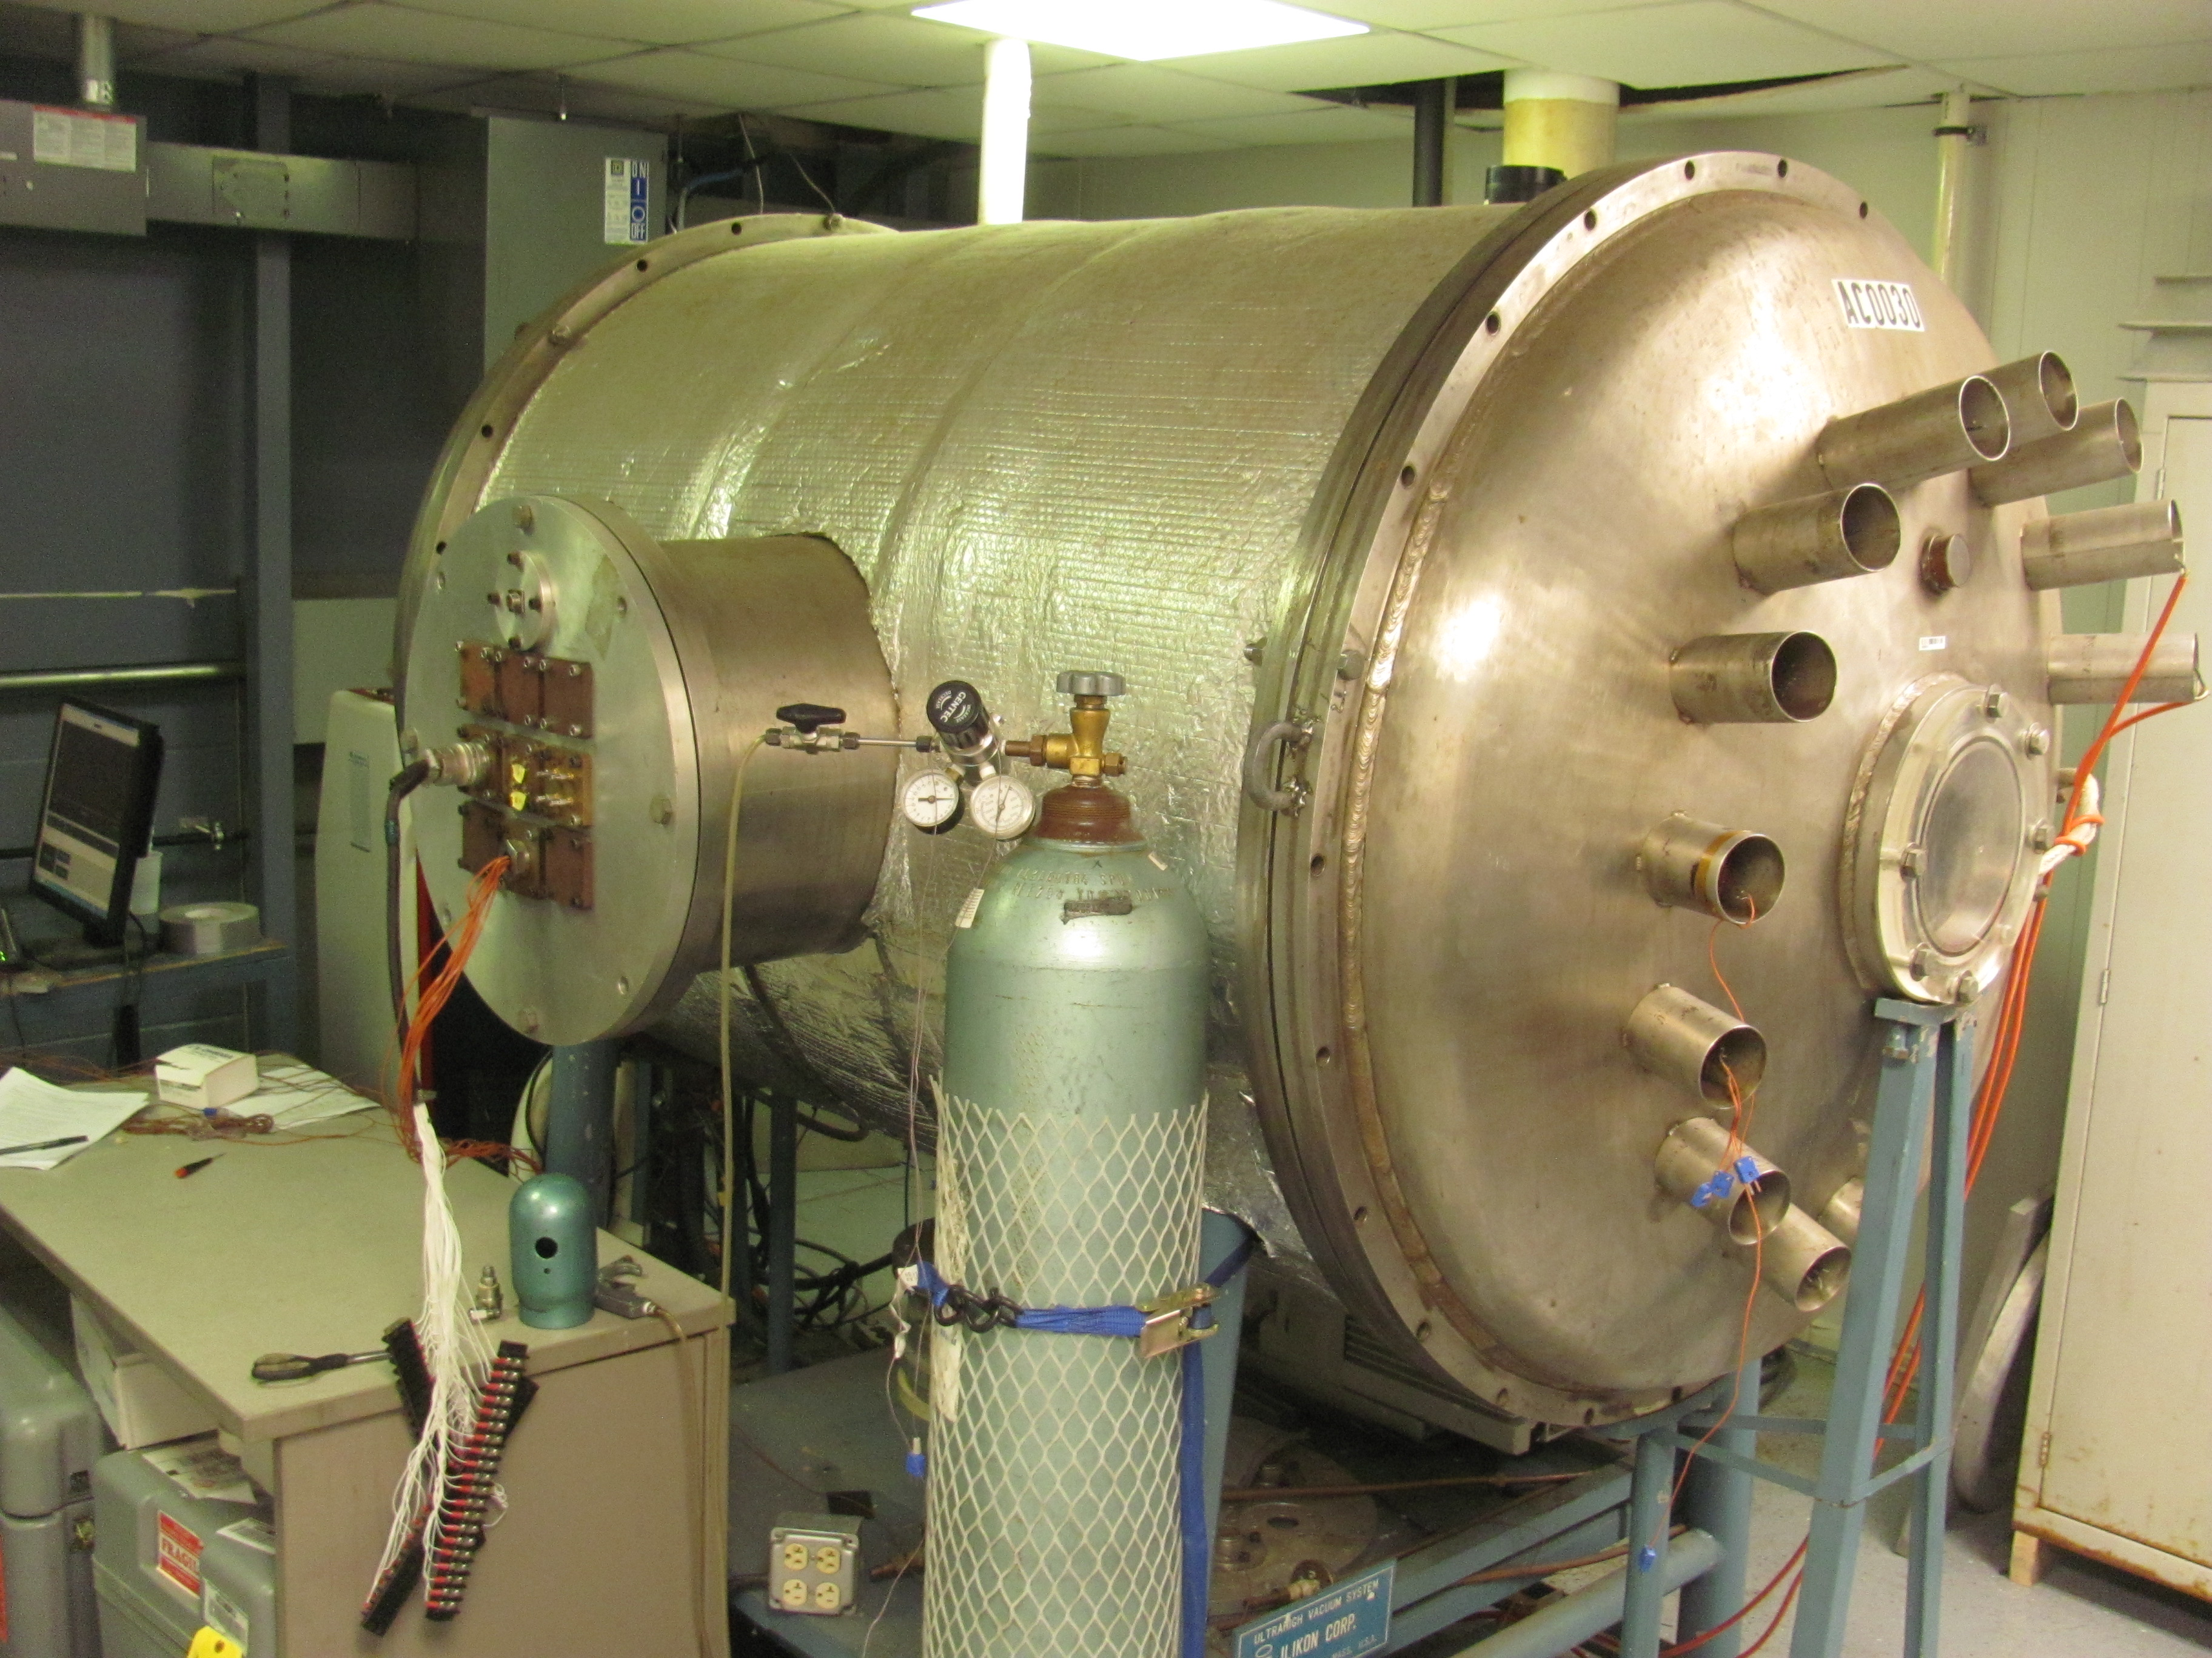

Figure 4 Bakeout chamber at NTS Boxborough

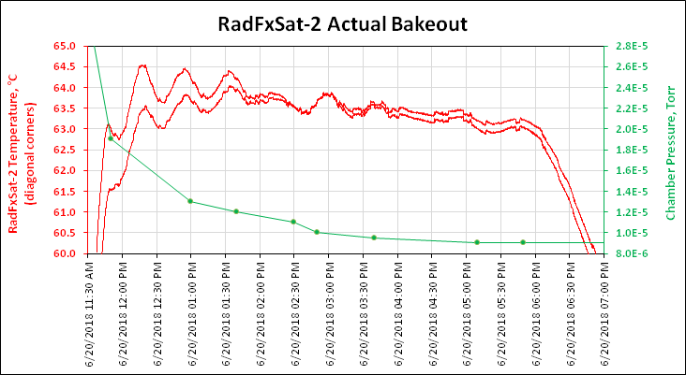

Figure RadFxSat-2 Actual Bakeout

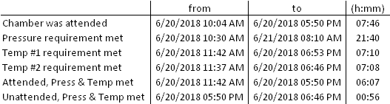

Table 2 Start/Stop Times and Durations

The full six hours of bakeout were attended. Both temperature sensors on the CubeSat were at least 60°C and the chamber pressure was below 1.0x10^-4 Torr. At the conclusion of six hours, the heaters were powered off which allowed thermal drift. The vacuum pump continued unattended until the following morning. After the full six hours, there was an additional 56 minutes that the bakeout requirements were met, but this was unattended.

After completion of Bakeout, the Aliveness Test, Short Functional Test, and CAC were all completed and passed, with the noted anomaly of REM experiment board not providing valid data during Short Functional Test (same result as after vibration).

1. **Summary**

On June 20, 2018, RadFxSat-2 completed Extended Duration Bakeout of at least six hours at >60°C and <1.0x10^-4 Torr.

1. **Compliance Certification**

I certify that RadFXSat-2 is in compliance with L1-VCLS-ICD-21 (ICD ¶3.6.5.3) (bakeout pressure) and L1-VCLS-ICD-22 (ICD ¶3.6.5.3.1) (bakeout temperature and duration).

Sincerely,

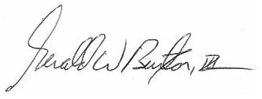

Gerald Buxton

Vice President – Engineering

AMSAT

(817) 573-2465